Aim

Write a program to illustrate how Template function can be overloaded.

Experiment - 30

Object Oriented Programming Lab

Syeda Reeha Quasar

14114802719

4C7

# **EXPERIMENT – 30**

## **Aim:**

Write a program to illustrate how Template function can be overloaded.

## **Source Code:**

#include <iostream>

using namespace std;

template <class T>

void f(T x, T y) { cout << "Template" << endl; }

void f(int w, int z) { cout << "Non-template" << endl; }

int main()

{

    f(1, 2);

    f('a', 'b');

    f(1, 'b');

}

## **Output:**

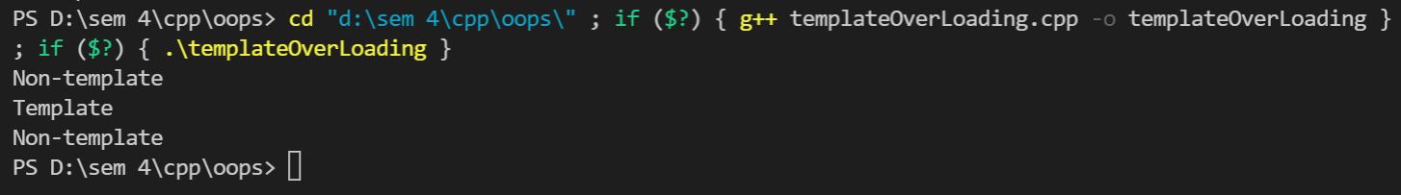

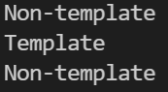

# **Viva Questions**

**Q1). What are templates in C++?**

Ans.

Templates are the foundation of generic programming, which involves writing code in a way that is independent of any particular type.

A template is a blueprint or formula for creating a generic class or a function. The library containers like iterators and algorithms are examples of generic programming and have been developed using template concept.

There is a single definition of each container, such as **vector**, but we can define many different kinds of vectors for example, **vector <int>** or **vector <string>**.

**Q2). How can templates be classified?**

Ans.

**Templates can be represented in two ways:**

* Function templates
* Class templates

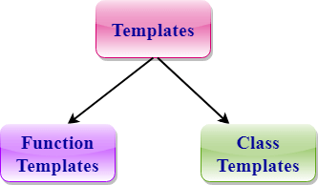

**Function Templates:**

We can define a template for a function. For example, if we have an add() function, we can create versions of the add function for adding the int, float or double type values.

**Class Template:**

We can define a template for a class. For example, a class template can be created for the array class that can accept the array of various types such as int array, float array or double array.

**Q3). Write about Function templates.**

Ans.

* C++ supports a powerful feature known as a template to implement the concept of generic programming.
* A template allows us to create a family of classes or family of functions to handle different data types.
* Template classes and functions eliminate the code duplication of different data types and thus makes the development easier and faster.
* Multiple parameters can be used in both class and function template.
* Template functions can also be overloaded.
* We can also use nontype arguments such as built-in or derived data types as template arguments.

**Q3) What is purpose of operator overloading?**

Ans.

The purpose of operator overloading is to provide a special meaning of an operator for a user-defined data type. With the help of operator overloading, you can redefine the majority of the C++ operators. You can also use operator overloading to perform different operations using one operator.